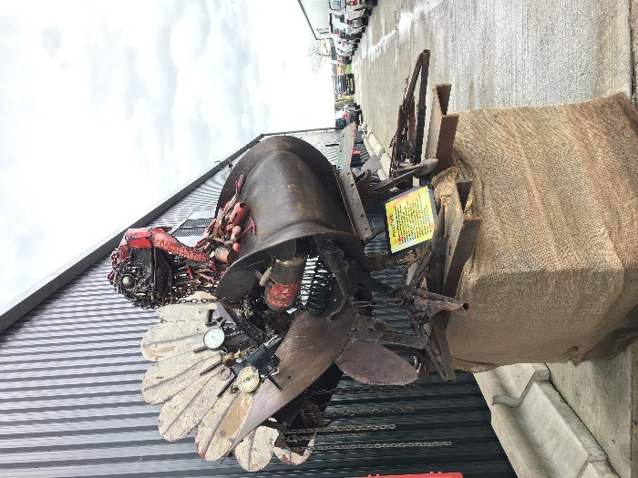**Kelly Conference   
– Howe Green, Sussex**

**14th March 2019**

**Notes:**

The Kelly Conference topics for this year included:

* Turkey Market Analysis
* 10 years from now
* Brexit
* The curse of the Butterfly and what to do
* Packaging Solutions

Interspersed with demonstrations on

* Small scale gas stunning
* Processing
* Breed Varieties

**NB: Presentations from all these talks are available on the BOS – see links at the end.**

**In summary:**

* Kelly Bronze started business in 1971
* Breeding was a big part of the business
* 41k breeders producing 2.6m eggs
* 26% of the fresh UK turkey market

Sites

* 3 sites in Ayrshire 18%, 2 sites in Northants 38% and 4 sites in Essex 44%

Breeders

* 3 primary turkey breeders left now since 1970 when there were about 15
* There are about 900 farmers throughout the country
* Disease is the farmers worst nightmare
  + All farms have stand-alone staff to stop disease transfer
* 28 pure lines ranging from 2kg - 30kg mature weights
* KB have the largest selection of coloured feathered birds, however the original Turkey feather colour was bronze
* Male line larger breast - lays less eggs
* Female longer keel bone and narrower breast - lays more eggs
* Currently doing trials on eggs and how well they hatch
* The birds need to mature for good fat covering which is needed so that they hang well

Suppliers to the market have reduced to just a handful now

* Bernard Matthews
* Avara foods
* Grove turkeys
* Gressingham
* Trd Norfolk poultry
* Capestone Poultry
* 800 small producers
* Moy Park stopped producing turkeys so this year there will be 600,000 less turkeys

Retailers:

* Supermarkets 8523
* Butchers, Farm shops, Farm Gate Delis - together about 8k
* Discounters have stabilised
* Costs of delivering products have increased by about 10% in supermarkets

Sales from the farmgate

* 12% breast, 71% whole bird and 17% crowns

**How do KB compete**

* The difference in length of time to produce is that KB birds have larger plumper breasts - even from a bird the same weight from a commercial breeder – which has taken less time to produce – the difference is that is hasn’t had time to lay down any muscle and fat
* KB have better population genetics
* They only choose the best for their customers and use the remaining birds for other products
* Looking at reproductive traits now, as KB feel the birds weights/ shape are about right now
* Dark meat is often darker due to the length of time it has taken to produce and is where the variety in flavours come from - breast meat often tastes the same. A shorter production time means lighter meat. Also feed will affect the flavour of a bird. Feeding on naked oats rather than oats in husk (less nutritious) towards the end of breeding - also makes a difference to flavour
* Super mini bird growth rate to 6kg is still 22weeks
* Commercial females were 20 weeks - but the change since 1970’sh is now 11weeks
* Slower growing birds will play a more important role at Christmas for retailers
* Currently slaughter at 26/27 weeks

**Gas Stunning**

A demonstration was given about an innovative new stunning system for small-scale turkey farmers

* The gas stunning process claims it is cost efficient (approx. 2-10p per bird) and has been Defra and RSPCA approved
* Available in either a multi box for groups or a single bird option
* Adaptable for different sized poultry
* Turkeys very calm going into the box, which looked like a holding pen
* It can perform 300 birds an hour for a 3’x6’ size system
  + And can be adapted for small scale producers to deal with 26 birds an hour
* Bigger systems are available
* It was claimed that gas is now preferred by RSPCA & Defra rather than electric
* The larger supermarkets and retailers are now requesting birds that have been slaughtered using these systems
* A 900 bird system can cost around £60-80k
* The gas is recycled – which further reduces costs
* Takes about 5 minutes for group stunning and the smaller one bird on-farm system takes just a few minutes
* Operator not affected by the gas, as it is held within the box system, and is an automated process which means less labour.

The production process

* Food grade wax used for dipping prior to plucking
* They are then dry plucked and hung which makes them costly
* Next process is removal of the feet then head, followed by an evisceration machine which removes the internal organs ready for the cavity and outer to be cleaned
* Then they are wrapped and boxed.

**Curse of the butterfly**

* On avg 50% of Butchers turkey sales at Christmas are the butterfly cut and they are often purchased from abroad – mainly because butchers can’t get UK butterflies in any quantity
* It is more costly and has a higher mark up

Why?

* Smaller gatherings
* Lower price per unit / less waste

What can farmers offer?

* Same product - higher price
* Local produce to uphold the butcher/farmer relationship
* Caution: If butchers don’t buy from local farmers they may not be there in the future

If available would Butchers buy?

* Price may be an issue as farmers can’t compete on price. Could farmers sell to butchers at £8+kg ?
* Issues: Disposal / use of the remaining carcase
  + A couple of suggestions was to put into pet food, produce Charcuterie products, add to the box wings and/or legs. Make gravy from bones.

Consumption

* Main purchase time is still Christmas, but groups are smaller and consumers want no left overs
  + Move to smaller birds (4 & 5kg’s)
  + Lower price point
  + Consumer preference to be priced per bird rather than per kg
  + Move to more people being flexitarian – eating less meat
* Farmers need to recognise the changes and offer Butchers the cuts consumers demand
  + However, farmers also need the right breed of Turkey which will give them best return

**Threats**

Brexit

* Possibly consumer spend?
* Tariffs?
* WTO may destroy British Ag

Activists

* Want to stop people eating meat
* Latest stats say population is currently - 1% vegan and 5% vegetarian
* Security can be relatively poor on small scale farms, so they need to be aware as it’s easy for someone to catch that time when things go wrong
  + Pecked birds - don’t look good
  + Casualty pens are a big risk
  + Dead birds - collect ASAP
  + Good husbandry is key
  + Lock up and look for break ins
  + Think: Am I happy to show my customers this?
* Drones also a big problem for farmers as activists try to record on farm activities.

Route to customer

* Butchers are not in growth and some are buying imported meat
* Online ordering makes it easy to shop with major suppliers
* Food miles and environmental issues for consumers and deliveries to small local businesses

**Further information and presentations:**

<https://bos.qguild.co.uk/pdf/Kelly_Bronze_Powerpoint_re_Market_Update_by_Paul_Kelly_-_March_2019_Conference.pdf>

<https://bos.qguild.co.uk/pdf/Kelly_Bronze_Powerpoint_re_Butchers_and_the_Butterfly_-_March_2019_Conference.pdf>

<https://bos.qguild.co.uk/pdf/Kelly_Bronze_Powerpoint_Turkey_Breeds-stats-numbers-Update_by_Paul_Kelly_-_March_2019_Conference.pdf>

<https://bos.qguild.co.uk/member-news/s/gas-stunning-now-for-small-turkey-producers>