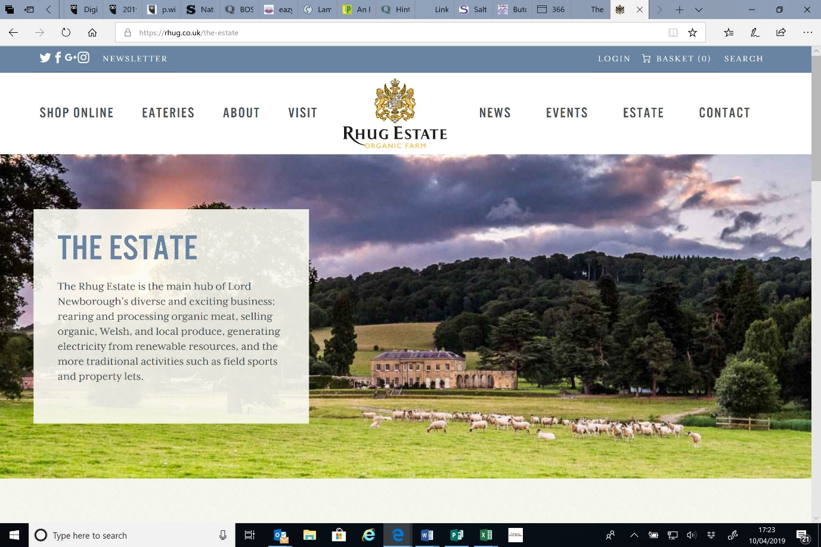[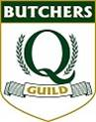](http://www.qguild.co.uk/)

**Monday 8th and Tuesday 9th April 2019**

**Minutes from Open Visit to Rhug Estate, Corwen, Wales and Hollies Farm Shop Little Budworth, Taporley**

**Attendees**

Mark Duckworth - Dales Butchers, Anthony, John, and John James Gornall – Honeywell’s, Philip Cranston, Martin Jones, Peter Potts, Rob McManus - Cranston’s, Andy Hull - Frasers, Sat Lola - William Jones Packaging, Sue and Claire Q Guild.

**Apologies**

Jan Corey, Johnathan Wallwork

**Monday 8th April 2019**

Set in this diverse landscape against a backdrop of stunning scenery the **Rhug Estate** has something for everyone.

Rhug Estate made retail history last summer when Lord Newborough opened a Drive Thru to complement the Bison Grill Bistro, Takeaway and Farm Shop at the entrance to Rhug farm estate. It is the first Drive Thru set up on a farm in the UK.

Members arrived for lunch in the bistro and then were taken on a tour of the meat cutting plant by Gary who had been with the business for many years. They employ 5 qualified butchers and 2 trainees on an in house apprentice scheme and they use Cambrian Training for the qualifications.

As we walked around Gary informed us of the various practices that Rhug get involved with or carry out.

* They have a stall on Borough Market in London which is open 4 days a week and is staffed by employees who live in the area. It does not make much profit but is a good way to raise awareness of the brand especially to their high-end market. Meat is transported from Wales 3 times a week to various hotels and orders as well as to stock the market stall.
* The production area was not very big considering it carries out all the bespoke delivery orders as well as requirements for the shop and restaurant. They also have a totally separate room for producing Halal meat and products.
* They seam butcher all their meat to ensure a consistent eating quality.
* 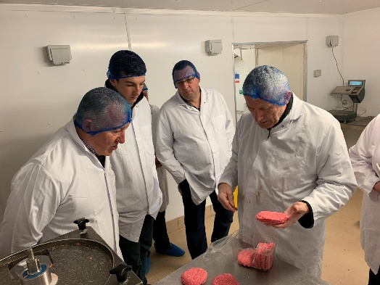All their meat is organic and what they do not farm themselves they also buy in as organic. Namely pork which they buy from East Anglia through Tulip. From which they produce and sell their own dry cured bacon and gammon hams which is all nitrate and nitrite free.
* Much of their meat is sent abroad to the Asian market, as their brand is very strong especially in Hong Kong, Singapore, Croatia and Dubai. For example last year their Turkeys were shipped to the king of Bahrain and their Dry Aged Beef is mainly used for the catering trade and is often sent to large hotels in Singapore where they often carry out demonstrations. Europe is not so big a market.
* They Dry age both their beef & lamb in an Himalayan salt wall chamber for anything between 28-68 days. There is also a dehumidifier installed which helps to keep it spore free, which means they can use the dry ends to make dry aged burgers for sale in the shop or restaurant. It took a while for Gary to convince the FSA, but through tests and perseverance they have now agreed it is safe.
* Worth noting - when they make their burgers (approx. 170gms) they don’t use any seasoning just mince and they always use ice in the meat instead of water. Installed in the packing room was an ice machine specifically for this reason.
* 650 chickens are processed a week which are returned from slaughter gas flushed
* 100-150 lambs a week are processed which weigh approx. 18- 24kg
* All their game is produced off site and cannot be called organic by its very nature. Venison is very popular at Rhug and is available from 3 nearby estates – Sika deer is also popular. Pheasants are sold as whole birds
* At Christmas they produce 1000 turkeys, currently wet plucked but are looking to move to dry plucked to enable a longer shelf life
* They have an online ordering system in place from Eureka – which they find works well
* Packing machines included a proseal skin pack machine which they find works well to extend shelf life, display their products as well as leaving space for labelling – which is worth noting they price everything before it leaves the site. This is based on an agreed rate with the customer usually trade +34%
* For the larger cuts they use an ammunition (mesh type) covering which is then shrink wrapped around the product, to give a 28 day shelf life which is great for products being sent abroad.
* They use a Rex sausage machine for consistent shaped sausages

Members were met by Gareth the farm manager who took members on a tractor and trailer farm tour.

* 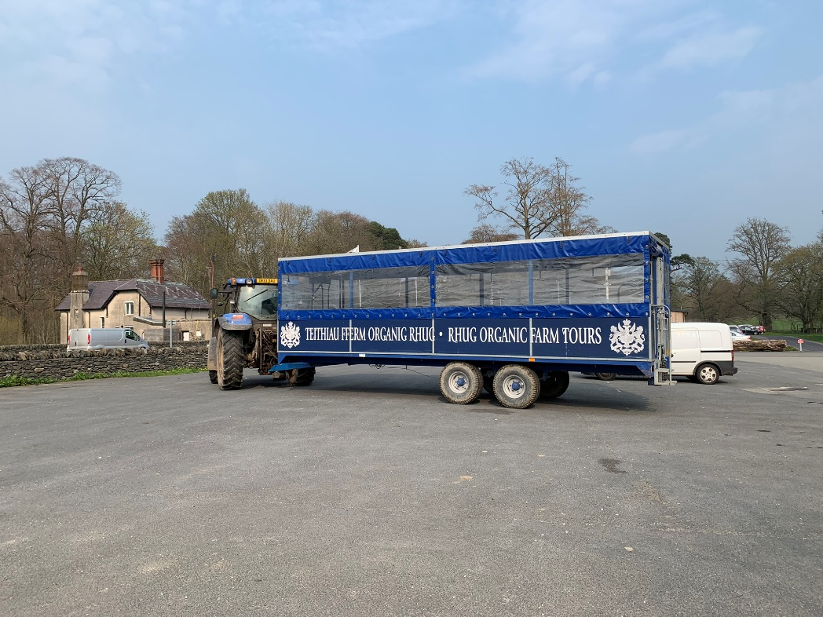The farm started with 2300 acres and is now at 4500 acres
* They farm using various schemes to comply with the organic status and for the well being of the land and animals.
* Farm tours are only available to pre booked groups
* Solar panels supply the main site with electricity, plus they have 3 or 4 hydro systems in place because water is better than windmills in the area.
* Being an organic farm to maintain sustainability, they follow a crop rotation usually over 2 years. They can’t grow continuous crops and so have rolling cereals, wheat, oats which they feed to the cattle

Cattle

* Currently they have 500-600 Cattle – Angus is the predominant breed. They also have 200 cattle on another farm and buy from other organic welsh farms. They have a few highland cattle but find them too slow growing, but are good for visitors to see.They use all their calves for beef and use a stabiliser bull to aid with fat cover and aid to maturing.
* They supply beef to their own shop and send the rest to Dovecote park at Pontefract for Waitrose.
* Cost for organic feed is £300 a tonne.

Sheep

* For lambing they have 2 on all day and night - 1500 ewes and 1000 mules. Cross Blueface Leicester and Swaledale. These make a good size ewe. They are inside the shed from January until they lamb. They can’t use nitrogen so they have less grass. There are a lot of costs to produce lamb organically – more space in a pen, clean grazing and rotational. They vaccinate using a 7 in one vaccine but don’t use antibiotics. They also blood test each year for any deficiencies
* Lamb weights are usually 18021 kgs. They sell Lamb to Waitrose through Randell Parker under the Duchy label and supply their own shop.
* In the summer the shed is used for events like lamb shearing and car events

**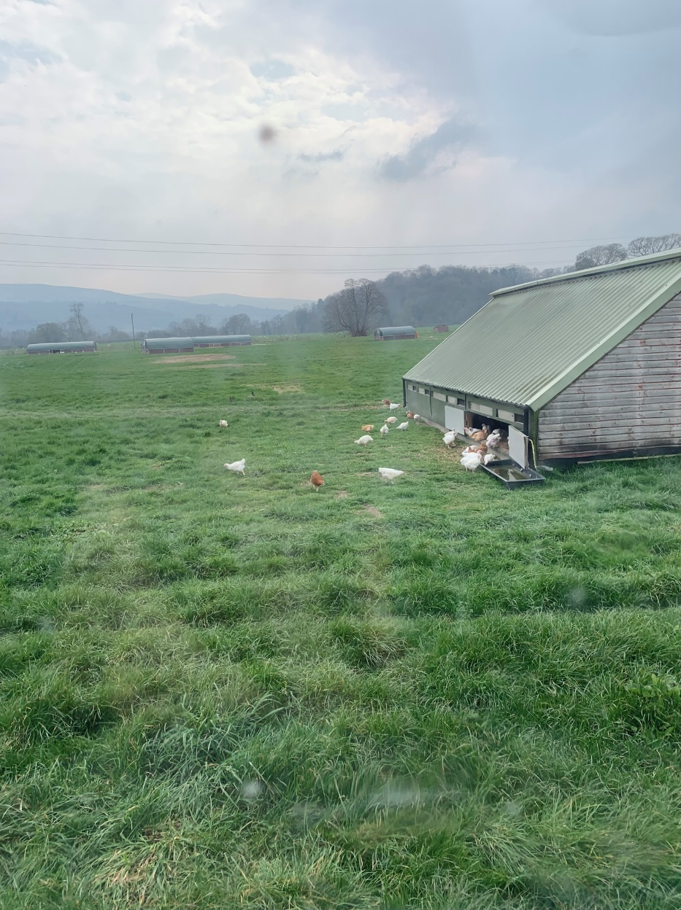**Chickens

* The supply 650 birds a week to the shop, outdoor – farming a slow growing breed - feed is very expensive at £450 a tonne!! and they use an artic wagon a month.
* They are slaughtered at 10-12wks by Baileys Turkeys of Knutsford, leaving the farm on a Wednesday night at 4pm and back the next day. To be certified organic they have to be the first kill of the day at the slaughterhouse. They also employ a halal slaughterer. The Christmas Turkeys are also taken to Baileys.
* The organic chicken meat is darker and more fibrous, but tastes better.
* Pipework for the water runs alongside the Chicken field which again is rotationally moved and is not particularly efficient – often freezes and splits in the winter.
* 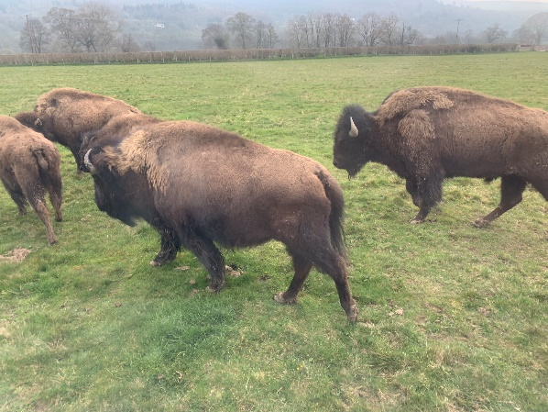The chicken sheds are moved as a whole item with a forklift around the field, each shed costs apprx £7-8,000

Bison

* The Bison herd numbering 20 are an indulgence of Lord Newborough. There all live in one field and are classed as dangerous. They don’t like to be handled, so the farmers only intervene if they really have to.
* They can suffer from Malignant Catarrall fever – a herpes virus which affects the respiratory tract.
* They are very hardy though and can survive at -20 temperatures so live outside all year.
* They are classed as wild animals and so with a vet onsite they are killed in the field at 30 months and then taken to the abattoir.
* They sell 1 a month in the shop mainly as burgers, braising and steaks. The meat tastes like gamey beef and is a very healthy low fat Red meat.

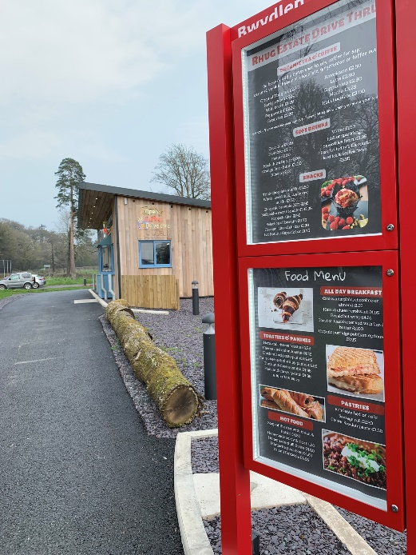

The tour ended with a drive through the Estate and Lord Newborough’s house could be seen on the hill side with a lake in front of it. The wings of the house were taken down in the 1970’s but it still had 9 bedrooms!

Hydroelectric is used and a duo system to heat the house. There is 200 acres of parkland around the house where sheep, cattle, 76 sika deer and fallow all graze. Oak and ash trees are being replaced to replicate the design of the parkland. They are in an environment scheme on the mountain which is 1700m high. They graze 450 ewes and 100 cattle on the mountain.

Drive Thru

* Opened in Sept 2018. It took time to get the planning as it had to be built above the flood plain. The main reason was to help with the summer season tourists on the way to Snowdonia and take some of the pressure away from the Bistro and takeaway café on site. The rule is prep time should be 70secs or less, and so no burgers are sold thro the drive thro, customers have to park up and visit the takeaway kiosk for those.

Members left Rhug at 4.30pm and headed for an overnight stay at Tarporley where a lovely evening meal was enjoyed at **39 by the Hollies** restaurant. <https://www.32bythehollies.co.uk/>

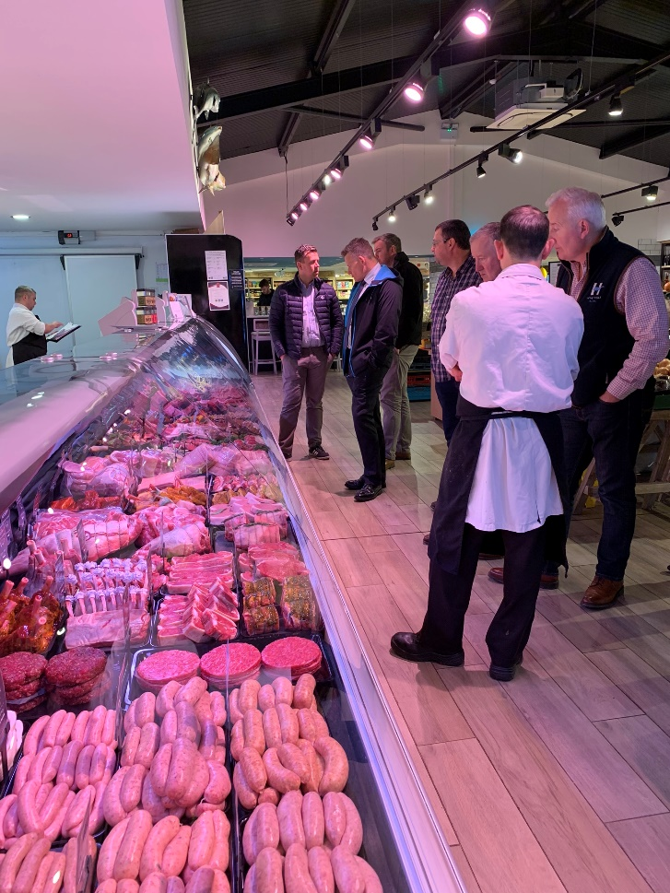**Tuesday 9th April**

Members met at the impressive **Hollies farm shop** for a Cheshire breakfast and were shown round the Farm Shop.

A FAMILY BUSINESS SINCE 1959

The Cheshire Farm Shop is brimming with produce from over 70 local suppliers combined with the finest goods from the local region, the UK and the world. Two farm shops with Butcheries, Coffee Shops, Deli, Gift departments, a Restaurant, 5 star self catering Forest Lodges and [Luxury Log Cabins](https://www.theholliesfarmshop.co.uk/log-cabins-luxury-lodges/) with private [hot tubs](https://www.theholliesfarmshop.co.uk/hot-tub-holidays-cheshire/), and a Highland Hotel in the Cairngorms National Park; [Muckrach Country House Hotel](https://www.muckrach.com/" \t "_blank).

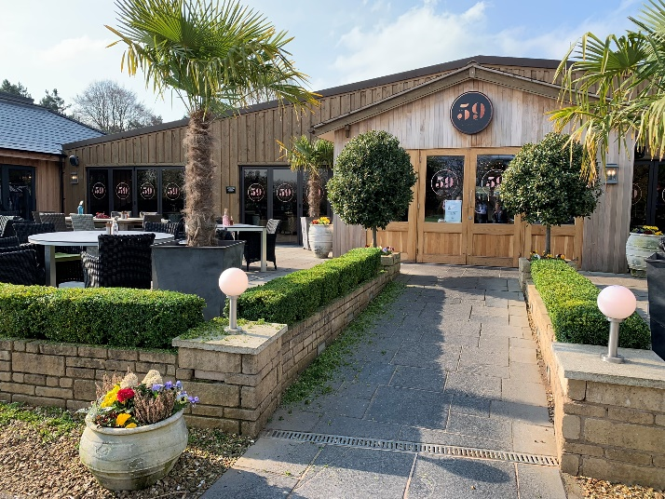Within the farm shop is a butchery counter which employs 3 butchers and 2 part time. They are very busy at the weekends. They only supply their own restaurant and coffee shop.

There other butchery is a smaller shop in Low Stretton. They are proud to say that they make their own sausages and burgers on site which are award winning.

The butchery counter was set out invitingly and looked wonderful and they work hard all year round to bring freshest, tastiest products to their counter.

Staff were thanked and Members left at 11am.

**Pls note there are lots more pics which we will load onto the BOS photo gallery**

Next Meetings.

**Monday 3rd June   
11 .30am Midlands BBQ Product Evaluation -** Scott Barlow, White Lion Hall Ln, Brinsley, Nottingham NG16 5AH

**Wednesday 26th June**  
**5.30pm-8pm -** All Members networking meeting at the Glasgow Radisson Blu where we have an interesting and informative line up of speakers

* Erin from **Verstegen** will demonstrate some innovative product ideas followed by a talk on dry aging and the use of salt walls
* **David Lishman** – will talk about his passion for all things Charcuterie
* We are hoping to secure **ActivDS** for a working demo of their in store screen media player.