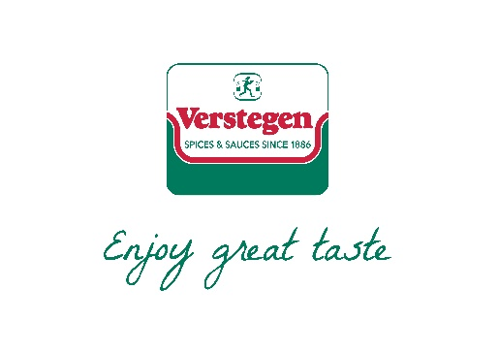**Presenting the Q Guild Butchers**

**Sponsors**



**Smithfield ‘Star’ Awards 2020 Lunch**

**To be held at the newly refurbished Butchers Hall   
  
on Tuesday 24th March 2020**

**TIMING**

**12.30pm -** Welcome drinks in the foyer

**1pm -** Lunch served in the impressive Great Hall

**3pm -** Awards Ceremony

**3.30pm –** GroupPhotographs

**4pm** – Finish

**Reserve your tickets today to ensure a place and be in with a chance of an   
‘under the chair’ surprise!**

Email [info@qguild.co.uk](mailto:info@qguild.co.uk) for an order form - Cost £80+Vat per person or a table of 8 for £600+Vat

**Smithfield ‘Star’ Awards 2020 Lunch**

**Venue: Butchers Hall, 87 Bartholomew Close, London, EC1A 7EB**

**Date: Tuesday 24th March 2020**

**Contact Name:**

**Contact Email:**

**Contact Telephone:**

**Business Name:**

**Address:**

**Purchase Order reference (if applicable):**

**Order Form**

Cost £80+Vat per person or a table of 8 for £600+Vat

|  |  |  |  |  |
| --- | --- | --- | --- | --- |
|  | **Name** | **Dietary Requirements** | Cost | Total |
| **1.** |  |  | £80 | £80 |
| **2.** |  |  | £80 | £160 |
| **3.** |  |  | £80 | £240 |
| **4.** |  |  | £80 | £320 |
| **5.** |  |  | £80 | £400 |
| **6.** |  |  | £80 | £480 |
| **7.** |  |  | £80 | £560 |
| **8.** |  |  | £40 | £600 |

**\*\*Last date for bookings is Monday 16th March\*\***

**Please send the completed form and cheque for the full amount to:**

**Q Guild, 8 Needless Road, Perth, PH2 0JW |** Cheques should be made payable to ‘Q Guild’.

Or email the form to [info@qguild.co.uk](mailto:info@qguild.co.uk) indicating you will pay via BACS payment

Guild of Q Butchers | Sort Code: 20-57-40 Account no. 30050199

Any cancellations made within 7 days of the lunch will be charged the full price.

**Presenting the Q Guild Butchers**

**Smithfield ‘Star’ Awards 2020**

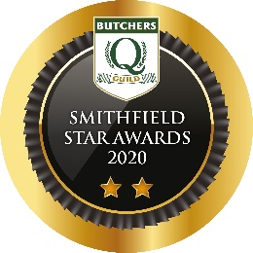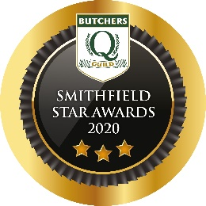

**Reasons to Enter:**

~ Showcase your craft butchery skills ~

~Encourage staff to enter their innovations ~

~ Drive up some friendly in store competition ~

~ Receive useful feedback from industry experts ~

~ Helps drive product development ~

~ Aim for that coveted title by beating the Best of the Best ~

~ Provides an opportunity to engage with your customers ~

~ Provides great content for social and local media ~

**Raises standards and recognises innovation and quality**

**Reviewed, Revamped and Updated!**

With 15 categories and 15 chances to achieve a Diamond Award let alone a new Star award, now is the time to enter. There are new categories, some with a twist plus a new one to recognise and reward your Young up and coming talent. Each product is judged blind by a team of expert judges, headed up by Institute of Meat, Chief Executive, Keith Fisher. Using a newly devised judging form which details more precisely the attributes of each product so you will get even more feedback. Products achieving a set standard will receive either a 3***, 2** or 1* Certificate. All 3*** achieving products go forward for the opportunity to be crowned a Diamond Award.

**Timeline:**

**Entries need to be submitted by Monday 20th January 2020**

**Products received for judging on Tuesday 4th February**

**Awards announced on Tuesday 24th March**

***Don’t miss out, involve your staff and get your entry form completed today   
– enter 6 and pay for 5. Email, post or enter online at*** [***entries.easydb.uk/qguild***](https://entries.easydb.uk/qguild)

**The very best of luck!**

**Categories Sponsors**



1. **A close up of a logo

   Description automatically generatedTraditional Pork** **Sausage** can include Traditional regional variations such as Cumberland, Lincolnshire, Lorne. Quantity 1lb (450g) uncooked
2. **Innovative Sausage** can include any flavour or meat type. Quantity 1lb (450g) uncooked
3. **A close up of food

   Description automatically generatedBest Burgers** can beany size or flavour profile. Quantity x4 large or x6 mini uncooked
4. **BBQ product** each product must be able to be cooked on a BBQ in under 30 minutes (not to include burgers or sausages). Quantity enough for two adult main meal portions.
5. A close up of a sign

   Description automatically generated**‘From the Deli’** can include charcuterie products such as salami sticks, pre-sliced ham, mortadella, pastrami, proscuitto, chorizo, or pate, rillettes and beef or lamb bacon. **No-pastry or scotch egg items permitted.**   
   Quantity min weight ½lb (227g) must be produced in the shop.
6. **Best Bacon Category** open to all types of pork bacon, any flavour cure. Quantity min weight 300g
7. **Kitchen Ready Meal** where all ingredients should be in an oven-able tray for cooking at home, the meat should be raw with added ingredients and as little prep as possible for the consumer.   
   Quantity, enough for 2 adult servings. ***Full cooking instructions must be included.***
8. A picture containing clipart

   Description automatically generated**Specialty Game Meat Product Hot Eating** such as a kitchen ready, ready meal or a hot sandwich filler, using any wild game such as pheasant, partridge, woodcock, snipe, woodpigeon, grouse, duck, goose, venison, rabbit, hare or squirrel. Quantity enough for 2 adult servings.   
   ***Full cooking instructions must be included.***

The following categories 9-14 are product specific and will change each year, this year they are as follows:

1. **Best Bakery** **Product - Hot Eating\*** in 2020 we’re looking for the best **Steak Pie,** wherethe main ingredient must be steak & may include other ingredients, precooked or uncooked pastry permitted, any size.   
   Quantity x2 family size or x4 individual pies. ***Full cooking instructions must be included***
2. **Best Bakery Product - Cold Eating\*** in 2020 we’re looking for the best **Traditional Pork Pie**. Any size of a traditional style pork pie (no other meat ingredient permitted). Quantity minimum x1 large pie, x2 medium, x4 mini.
3. **Gluten Free Product\*** in 2020 we’re looking for the best **Gluten Free Sausage** produced with any meat type and flavor. Quantity 1lb (450g) uncooked
4. **Naked Steak\*** in 2020 we’re looking for the best **8oz sirloin steak**, quantity x4 8oz steaks with no added seasoning.
5. **Artisan Product\*** for 2020 is **Black Pudding** to be produced in the shop, any flavor profile. Quantity min ½lb (227g)

1. **Best Q Guild Butchers Shop Promotional Meat Display** in 2020 we’re looking for the best **Fresh Meat display.** To be judged from x5 photos submitted, showing up to **1mtr of counter display.** One picture should show the butcher(s) involved in creating the display. One photo from each entrant will be displayed on a board at the Awards Lunch and afterwards all images will be produced into an online pdf and flip book. So please make sure they are hi resolution/ good quality images.
2. **Q Guild Young Butcher of the Year** open to allYoung Butchers aged under 24yrs on 24th March 2020. Nominations to come from the business owner or shop manager who they work for, to include a description and picture of a new product they have developed and sold in the shop accompanied by a description of other work the young butcher carries out and why they deserve to be the Q Guilds Young Butcher of the Year.   
   **Entry to this category is free**, send a photo of the product, the young butcher and approx. 250 words on how they are a great asset to the shop. 1 awards lunch ticket will be available for each of the three finalists who must be able to attend the lunch on 24th March 2020 in London.