Presenting the Q Guild Butchers**

**Sponsors**

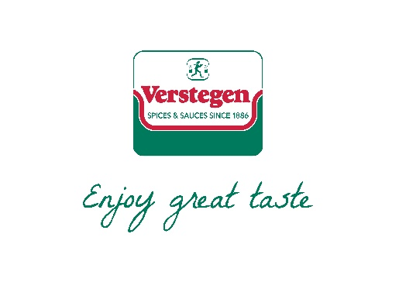

**Smithfield ‘Star’ Awards 2020**

**To be held at the newly refurbished Butchers Hall   
  
on Tuesday 24th March 2020**

**TIMING**

**12.30pm -** Welcome drinks in the foyer

**1pm -** Lunch served in the Great Hall

**3pm -** Awards Ceremony

**3.30–4pm** GroupPhotographs & Close

**Reserve your tickets today to ensure a place and be in with a chance of an ‘under the chair’ surprise!**

**Smithfield ‘Star’ Awards 2020 Lunch**

**Booking Form**

**Venue: Butchers Hall, 87 Bartholomew Close, London, EC1A 7EB**

**Date: Tuesday 24th March 2020**

**Contact Name:**

**Contact Email:**

**Contact Telephone:**

**Business Name:**

**Address:**

**Purchase Order reference (if applicable):**

**Order Form**

|  |  |  |  |  |
| --- | --- | --- | --- | --- |
|  | **Name** | **Dietary Requirements** | Cost +VAT | Total |
|  |  |  | £80 | £80 |
|  |  |  | £80 | £160 |
|  |  |  | £80 | £240 |
|  |  |  | £80 | £320 |
|  |  |  | £80 | £400 |
|  |  |  | £80 | £480 |
|  |  |  | £80 | £560 |
|  |  |  | £40 | £600 |

**\*\*Last date for bookings is Monday 16th March\*\***

**Please send the completed form and cheque for the full amount to:**

**Q Guild, 8 Needless Road, Perth, PH2 0JW |** Cheques should be made payable to ‘Q Guild’.

Or email the form to [manager@qguild.co.uk](mailto:manager@qguild.co.uk) indicating you will pay via BACS payment

Guild of Q Butchers | Sort Code: 20-57-40 Account no. 30050199

Any cancellations made within 7 days of the lunch will be charged the full price.